Project Logo Competition - Call for design concepts

The recently launched DAAD “Global Water and Climate Adaptation Center” – or ABCD Center, corresponding to the 4 cities in which the project partners are located: Aachen (RWTH Aachen, Germany), Bangkok (AIT, Thailand), Chennai (IITM, India) and Dresden (TU Dresden and UNU-FLORES, Germany) is announcing a competition for designing a project logo and visual identity that will reflect the objectives of the Center.
The competition is open to all and we invite you to design a creative, original, and straight-forward logo that will accompany the project’s activities. The image selected will appear on ABCD-Center events, social media, and all our visual materials.

The winner will receive 1,000 Euros and the designer will be given a special mention.

About the ABCD Center
The international community is still facing urgent global climate and environmental problems and their importance for sustainable development have been made even more clear by the ongoing pandemic. In this context, the German Academic Exchange Service (DAAD) with funds from the Federal Foreign Office is supporting the establishment of Global Centers for the interdisciplinary networking of science, policy, economy and civil society for an effective transfer of research results into practice.

The School of Civil and Environmental Engineering of TU Dresden and the RWTH Aachen were successful with a joint application. Together with partners from the Indian Institute of Technology Madras (Chennai, India), the Asian Institute of Technology (Bangkok, Thailand) and the Institute for Integrated Management of Material Fluxes and of Resources at the United Nations University (UNU-FLORES) in Dresden, the ABCD Center will deal with climate adaptation measures in the Global South, especially in the water sector. Scientists will work closely together in three thematic clusters across disciplines:

- Water Security, Water Resource Management, Safe Water Supply and Water Treatment
- Ecosystem Resilience and Nature-Based Adaptation Measures
- Transfer Strategies: Traditional knowledge, Local Economies and Social Acceptance

The new Global Center not only promotes the mobility of young researchers and provides scholarships for master’s and doctoral students, but also develops a new joint international M.Sc.-course on the subject of “Water Security and Global Change”. In order to effectively counter the effects of the pandemic and to further optimize future exchange in research and teaching, great emphasis will be placed on the implementation and further development of digital formats. Furthermore, a network is to be established with three other Global Center for Climate and Environment, and with the four Global Center for Health and Pandemic Prevention, which have been established at the same time. The topic of water obviously plays a central role and it builds on the internationally renowned expertise and the resources available in the field of construction and the environment at the TU Dresden and the partners involved. The exchange of students, doctoral candidates and lecturers is intended to create an effective network to stimulate further research projects, but also to pave the way for a successful transfer of knowledge and technology with the involvement of business, politics and civil society.

The research scope of the ABCD Center falls in line with the UN 2030 Agenda and tackles Sustainable Development Goals (SDGs) including, but not limited to, Goal 6 (Clean water and sanitation) and Goal 13 (Climate action).

Logo Details
Together with the logo proposal, each applicant must send a short description of the logo and the idea behind it. For quality reproduction purposes the graphic proposal has to be submitted in a scalable vector graphic format (EPS). The colour code must be CMYK. Contestants are advised to avoid gradients and half-tones. The logo must be easy to use, handle, resize, and manipulate for all reproduction purposes. It should be visually appealing on both small and large scales.

For sharing purposes, each applicant has to include, together with the EPS format, three other formats: PDF, JPG and PNG (the latter with transparent background).

Logo Submission
Logo proposals have to be sent to abcd-centre@tu-dresden.de by 15.10.2021 with the subject: ABCD Center LOGO CONTEST.
Every submission must be provided with the official entry form. Individuals or teams (up to 2 persons) may submit only one design – no exceptions!

Selection Process
The winning design will be selected by the ABCD Center Steering Committee, representing the project leads from all partner institutions. The logo will be selected based on its relevance to the project, originality, and aesthetic quality.

Intellectual Property
The submitted logo design must be original and has not been copied from others or from previous designs, including their own, and does not infringe on the rights of any third party.
Anyone violating others’ copyright will be disqualified from the competition. If the winner is found to have violated any rules, he/she will be required to forfeit or return the prize, even if the violation is discovered after the prize has been awarded. The ABCD Center does not bear any responsibility for copyright violations or infringements of intellectual property carried out by the contestants.

Logo designs with a watermark will not be accepted. The winning logo becomes the sole property of the ABCD Center. The project team shall have the right to adapt, edit, modify, or otherwise use the logo. All intellectual property rights in the selected logo design are deemed assigned to the ABCD Center.

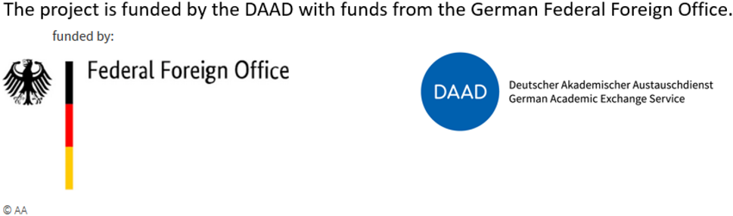

ABCD Center Official Entry Form

Contact Details – Designer #1
Name:
Address:
City: | Country: |  | ZIP Code:
Phone: |  |  | Email:
Contact Details – Designer #2
Name:
Address:
City: | Country: |  | ZIP Code:
Phone: |  |  | Email:
Logo Description
Please describe the idea behind your logo design:

Required Signatures
Participation in the ABCD Center Logo Design Contest constitutes the entrant’s full and unconditional agreement to and acceptance of the contest’s official rules. Each entrant further understands that if her/his logo design is selected as the winner, she/he will relinquish all claims, rights (including any moral rights), and benefits related to the display, modification, reproduction, publication, distribution, use, and other exploitations of the work, other than the prize awarded to the winning entry. This form must accompany all contest submissions.

Signature – Designer #1: |  | Date:
Signature – Designer #2: |  | Date:

